Rentals, Weddings and Private Parties
Host your special event at the Heritage Farmstead Museum, where we have beautifully landscaped grounds, authentic architecture, and outside caterers are welcome. Note: A minimum of 4 hours and/or $850 rental fee required for all after hour events:
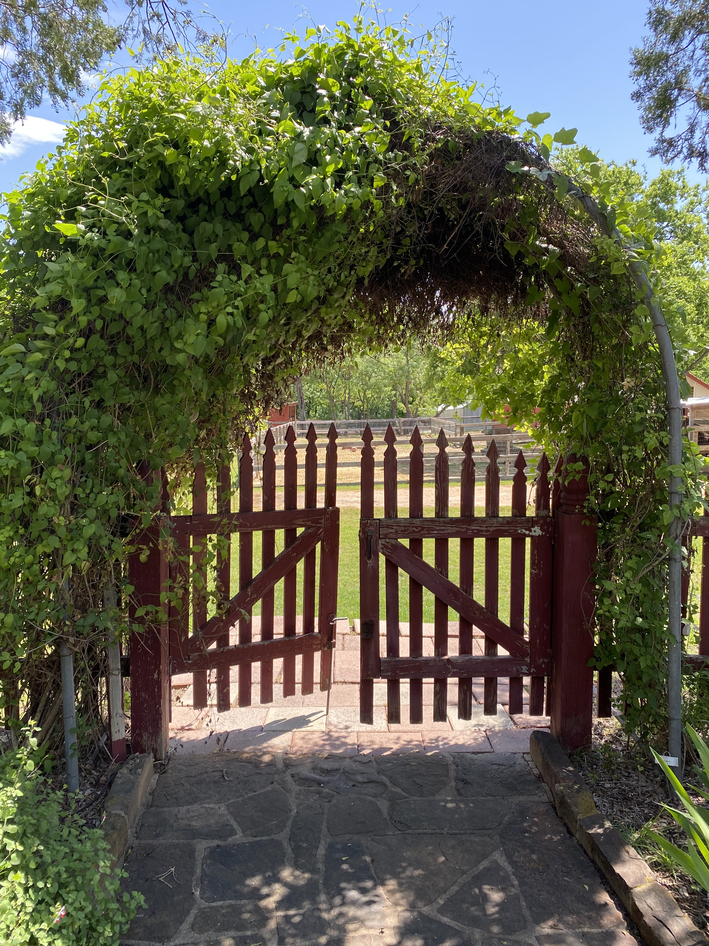

The Heritage Farmstead Museum represents farm life on the Blackland Prairie from 1890 through 1920. Built by Hunter Farrell in 1891, the four-acre site is listed on the National Register of Historic Places, and is also a state and local historic landmark. Originally, this site was the hub of a 360-acre working farm and was operated in later years by Miss Ammie Wilson, one of Plano’s most colorful citizens and a world champion Hampshire sheep breeder. Following her death in 1972, the Heritage Farmstead Association, founded just one year later in 1973, researched, planned, and raised funds for an extensive restoration project. In October of 1986, the Farmstead opened for the first time to the public as a living history museum.
Today, the Farmstead welcomes over 35,000 annual visitors who participate in tours, educational programs, field trips, lectures, and special events. Financial support for the museum is provided in part by tour admissions, rentals, corporate and private donations, as well as memberships. The Farmstead has artifacts of significant historical value. Therefore, it is vital that visitors respect this valuable landmark so that its beauty and historical worth may be preserved for future generations.
Tucked away in central Plano, the Heritage Farmstead is the perfect place to step away from the hustle of the city. The Farmstead welcomes weddings, reunions, scout camp-outs, birthday parties, company picnics, barn dances, receptions, corporate events and retreats.

Front Porch & Parlor Garden
This peaceful setting makes for a beautiful backdrop for a wedding, garden tea party, cocktail hour or small reception. This front yard area of the historic Farrell-Wilson house accommodates up to 50 people seated round-table style, or up to 100 people ceremony style.

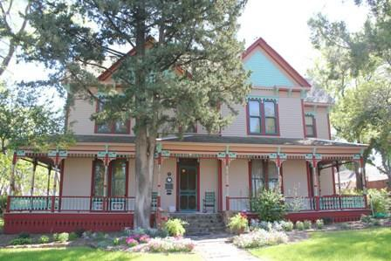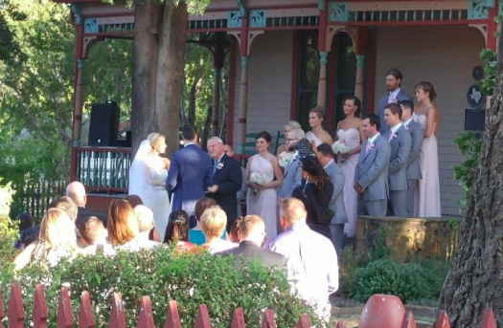

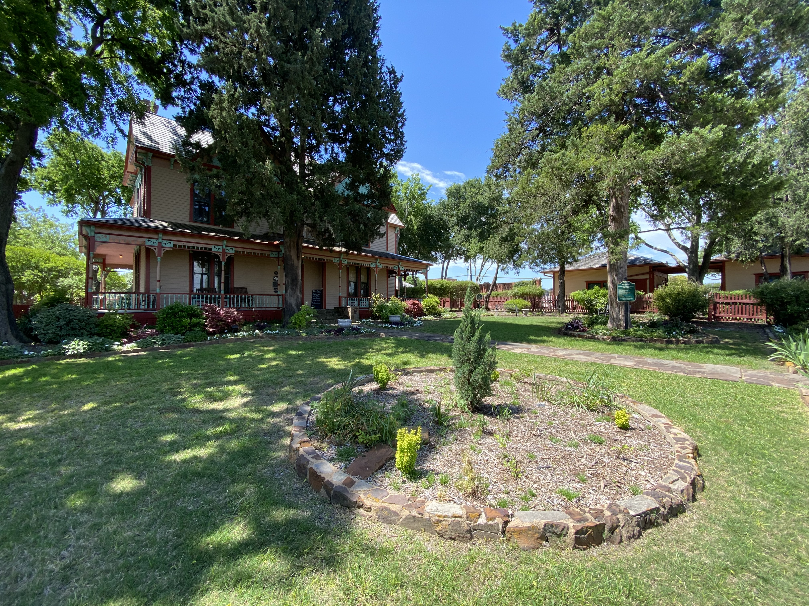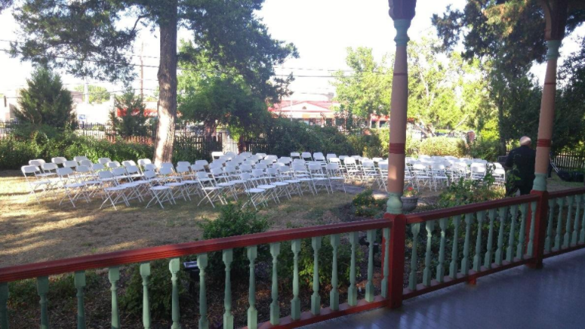

Square Feet: 80’x30’

Capacity: Up to 50 people round-table style.
Up to 100 people seated ceremony style.

ADA accessible: Yes

Music: Electrical outlets accessible, band
Note: A minimum of 4 hours and/or $850 rental fee required for all after hour events.

Rental Duration: 4 hour rental

Rental Rate:
Up to 50 people: $500
Additional hour: $125
51-100 people: $700
Additional hour: $175

Refundable Security Deposit: $500

Back Porch & Garden Area
This small but lovely area can accommodate groups similar in size to the front porch area, and is great for events such as cocktail hours or small receptions.

Square Feet: 93’x20’

Capacity: Up to 50 people seated ceremony-style
Up to 100 people standing reception

ADA accessible: Yes

Music: Electrical Outlets accessible, band

Note: A minimum of 4 hours and/or $850 rental fee required for all after hour events:

Rental Duration: 4 hour rental

Rental Rate:
Up to 50 people: $500
Additional hour: $125
51-100 people: $700
Additional hour: $175

Refundable Security Deposit: $500

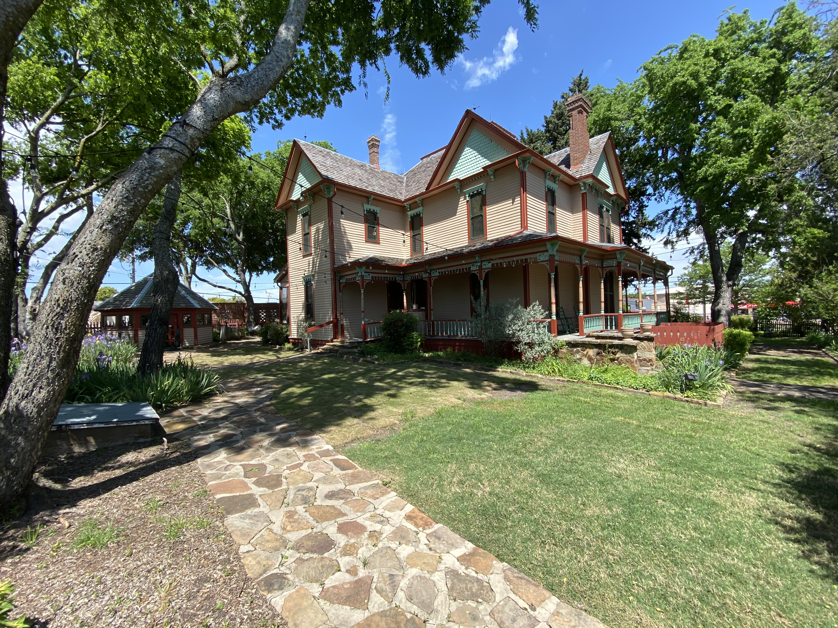
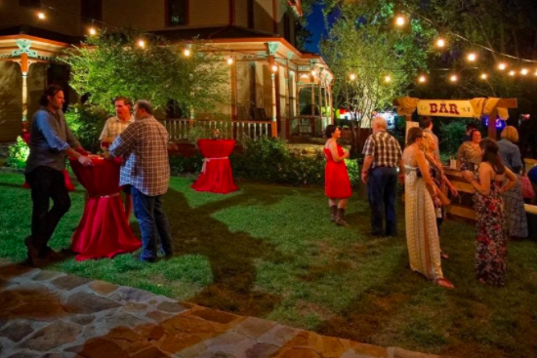

Pole Barn
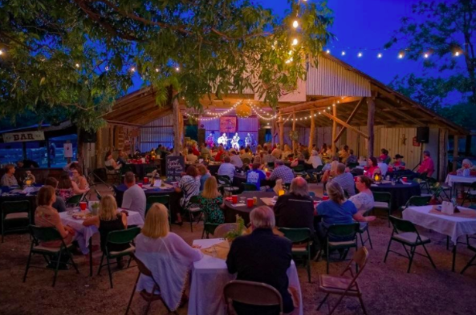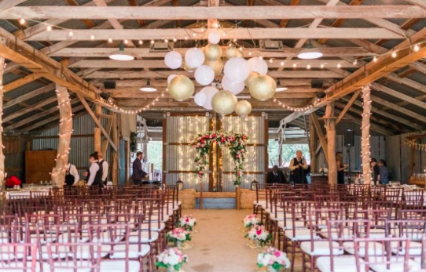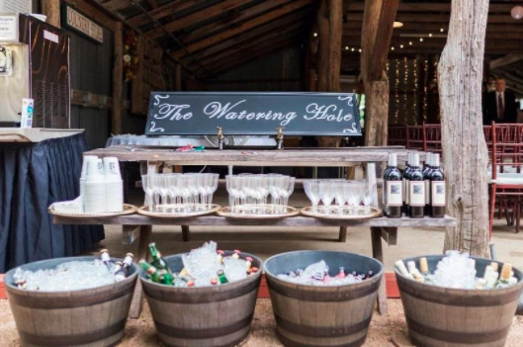

The Pole Barn, built from bois d’arc logs hauled from the Red River area, may actually pre-date the Farrell-Wilson House. This structure originally functioned as an animal barn and machinery shed. The partition with sliding doors stored the hammer mill where grain could be ground in bad weather. The concrete floor was added during restoration, but the poles, sides, and roof are all original.
The Pole Barn (44’ x 47’) contains two large overhead ceiling fans, lighting, as well as hook-ups for a DJ or band. A long banquet table (2’6” x 11’2”) is permanently placed at the north side of the barn. Stage is adjustable. There are 10 picnic tables (3’ x 6’) available or 6’ round tables to use at no additional cost. The front of the barn is open to allow guests to move comfortably onto the grounds. This open-air space with a fire pit offers partial shade as well as additional seating.

Square Feet: 2000’

Capacity: Up to 100 round-table style
Up to 150 ceremony style Additional seating available outside of Barn for up to 300

Music: Electrical Outlets accessible, microphone system, DJ, Band

ADA accessible: Yes

Rental Duration: 4 hour rental

Rental Rate:
Up to 100 people: $850
Additional Hour: $200
101-200 people: $1200
Additional Hour: $300
201-300 people: $1600
Additional Hour: $400

Refundable Security Deposit: $500

Climate Control: 2 large overhead fans

Note: A minimum of 4 hours and/or $850 rental fee required for all after hour events:

The Young House
In 2001, this 1880s farmhouse was moved to the Heritage Farmstead Museum grounds from its original site near Independence Parkway and Highway 121 in far north Plano. The Young House can be rented for meetings, lectures, tea parties, and team-building exercises. The Young House can also be rented as a changing room for the Bridal Party.

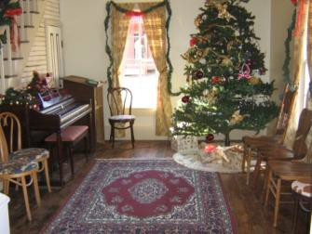
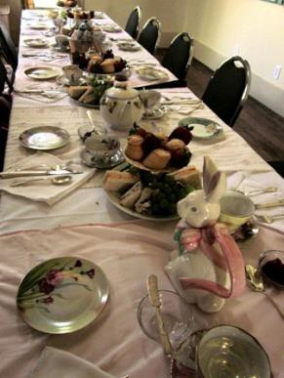
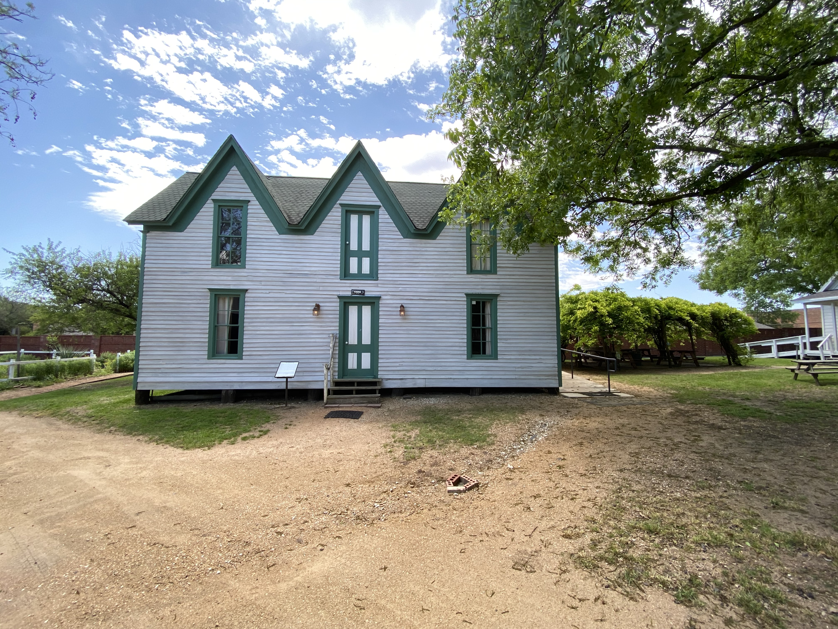

Square Feet: 500’

Capacity: Up to 40 people

Music: Electrical Outlets accessible

ADA accessible: Yes
Climate Controlled: Air conditioned and heated

Rental Duration: 4 hours

Rental Rate:
Up to 40 people during business hours: $400
Additional Hour: $100

Refundable Security Deposit: $500
Note: A minimum of 4 hours and/or $850 rental fee required for all after hour events:

Small Meadow
This partially shaded grassy area behind the School House lends itself to games and other activities requiring open space. Games, booths, tractor rides, wedding ceremonies and receptions are just some of the possibilities you may wish to consider in this large, versatile area.

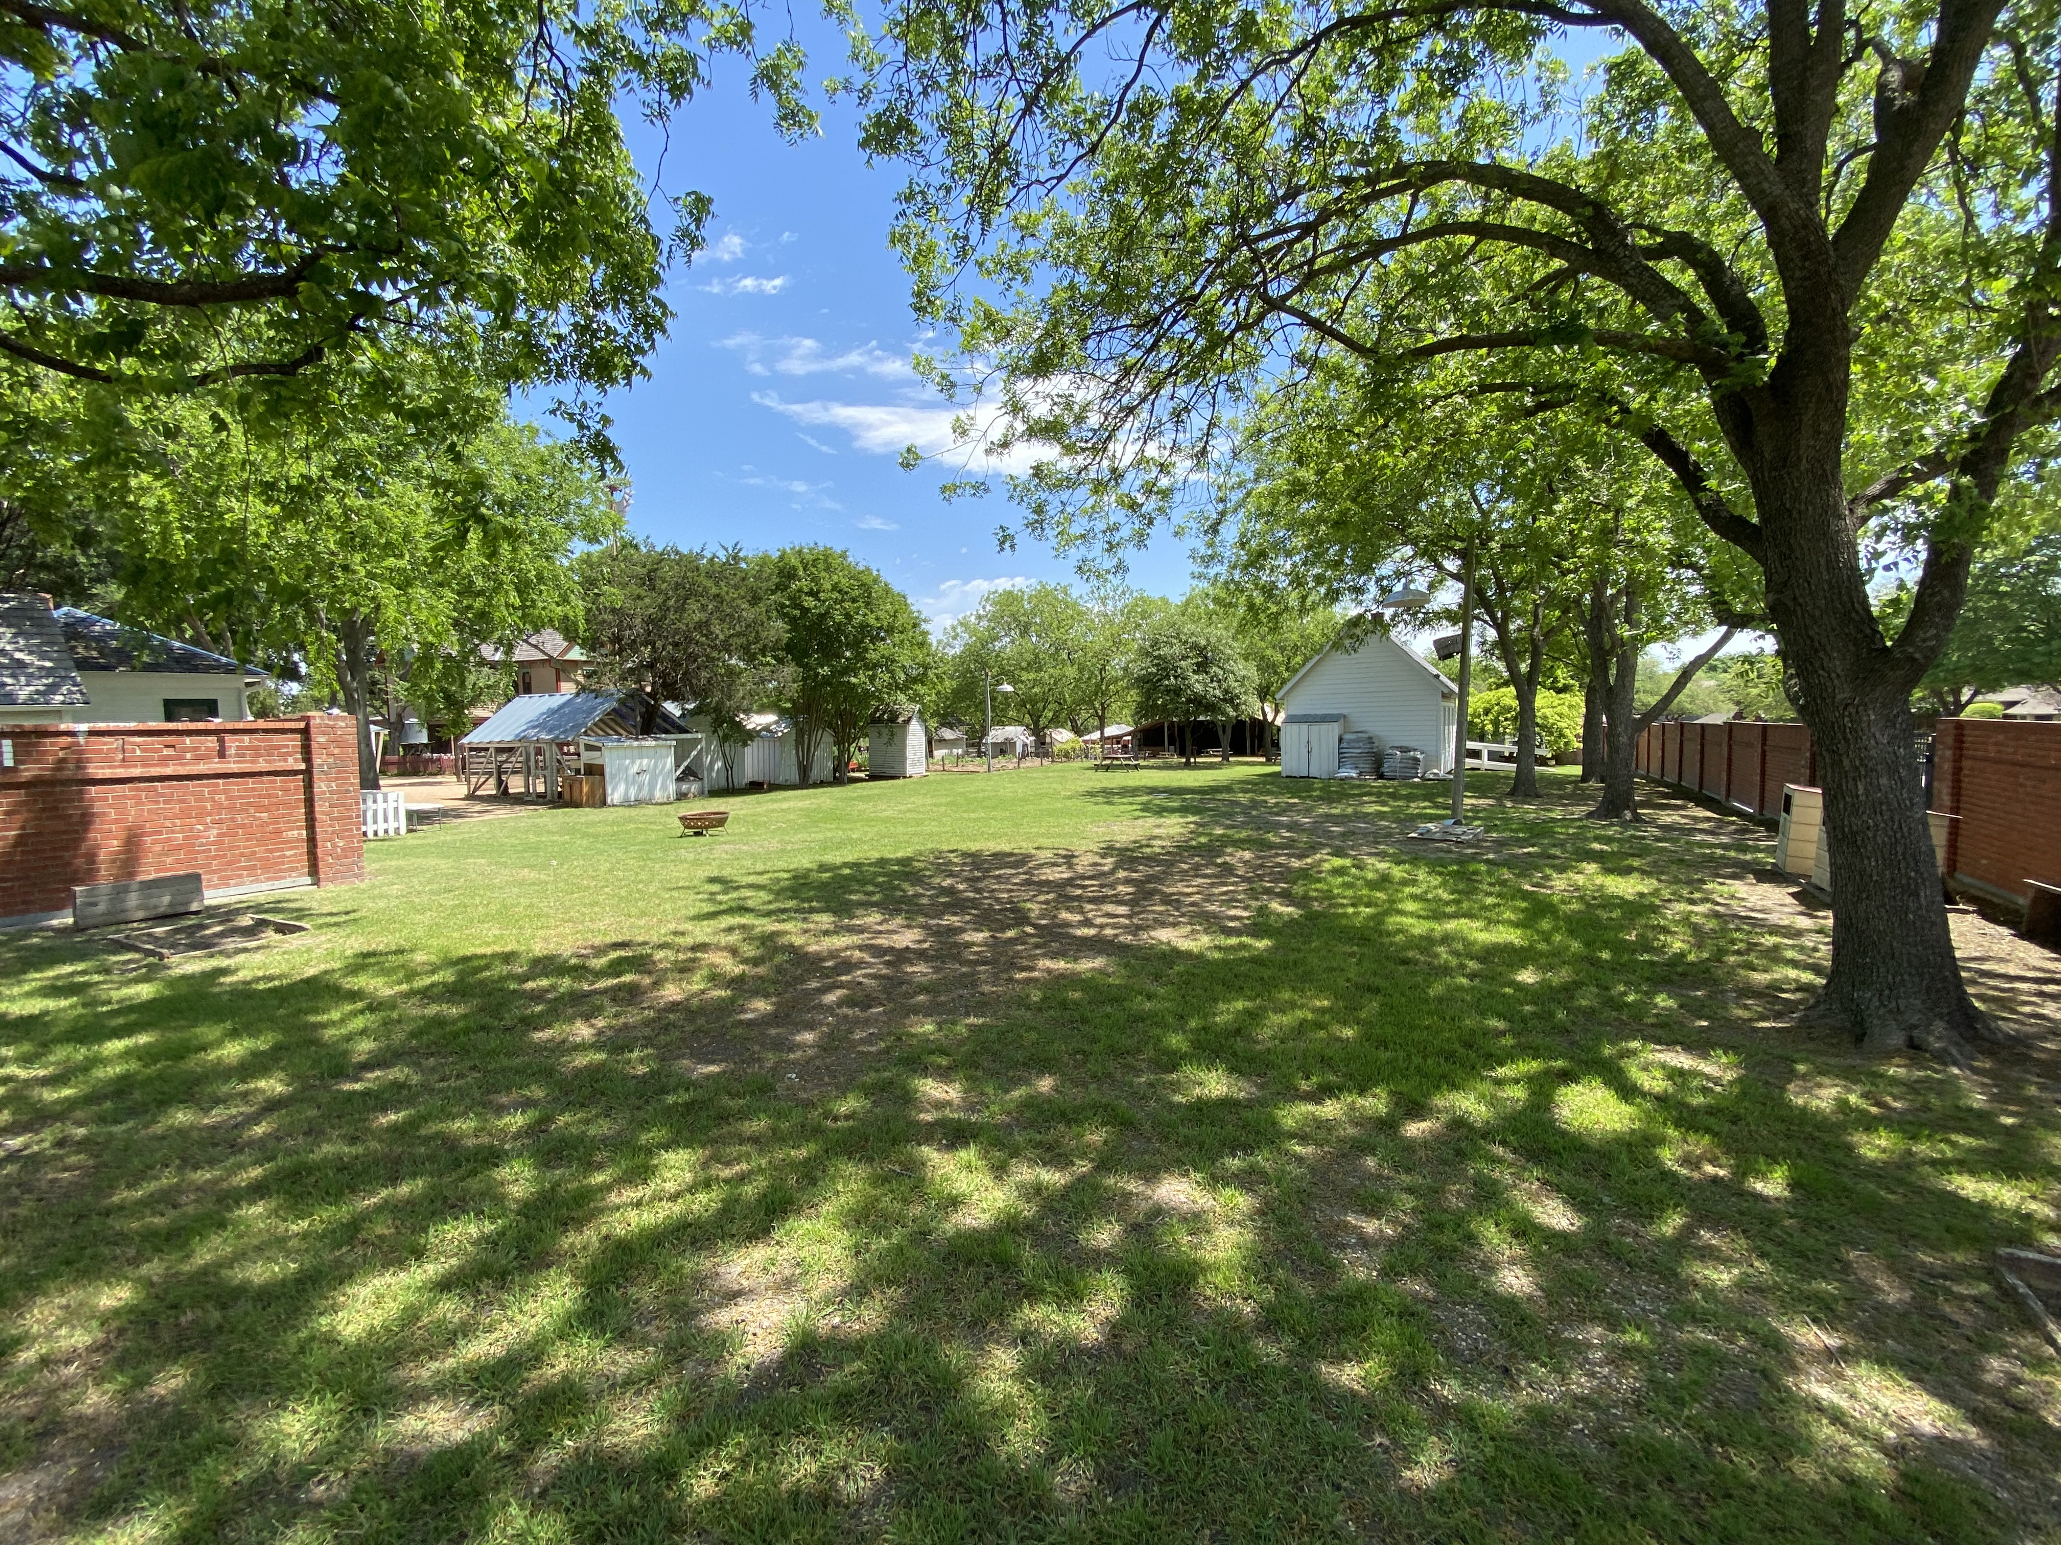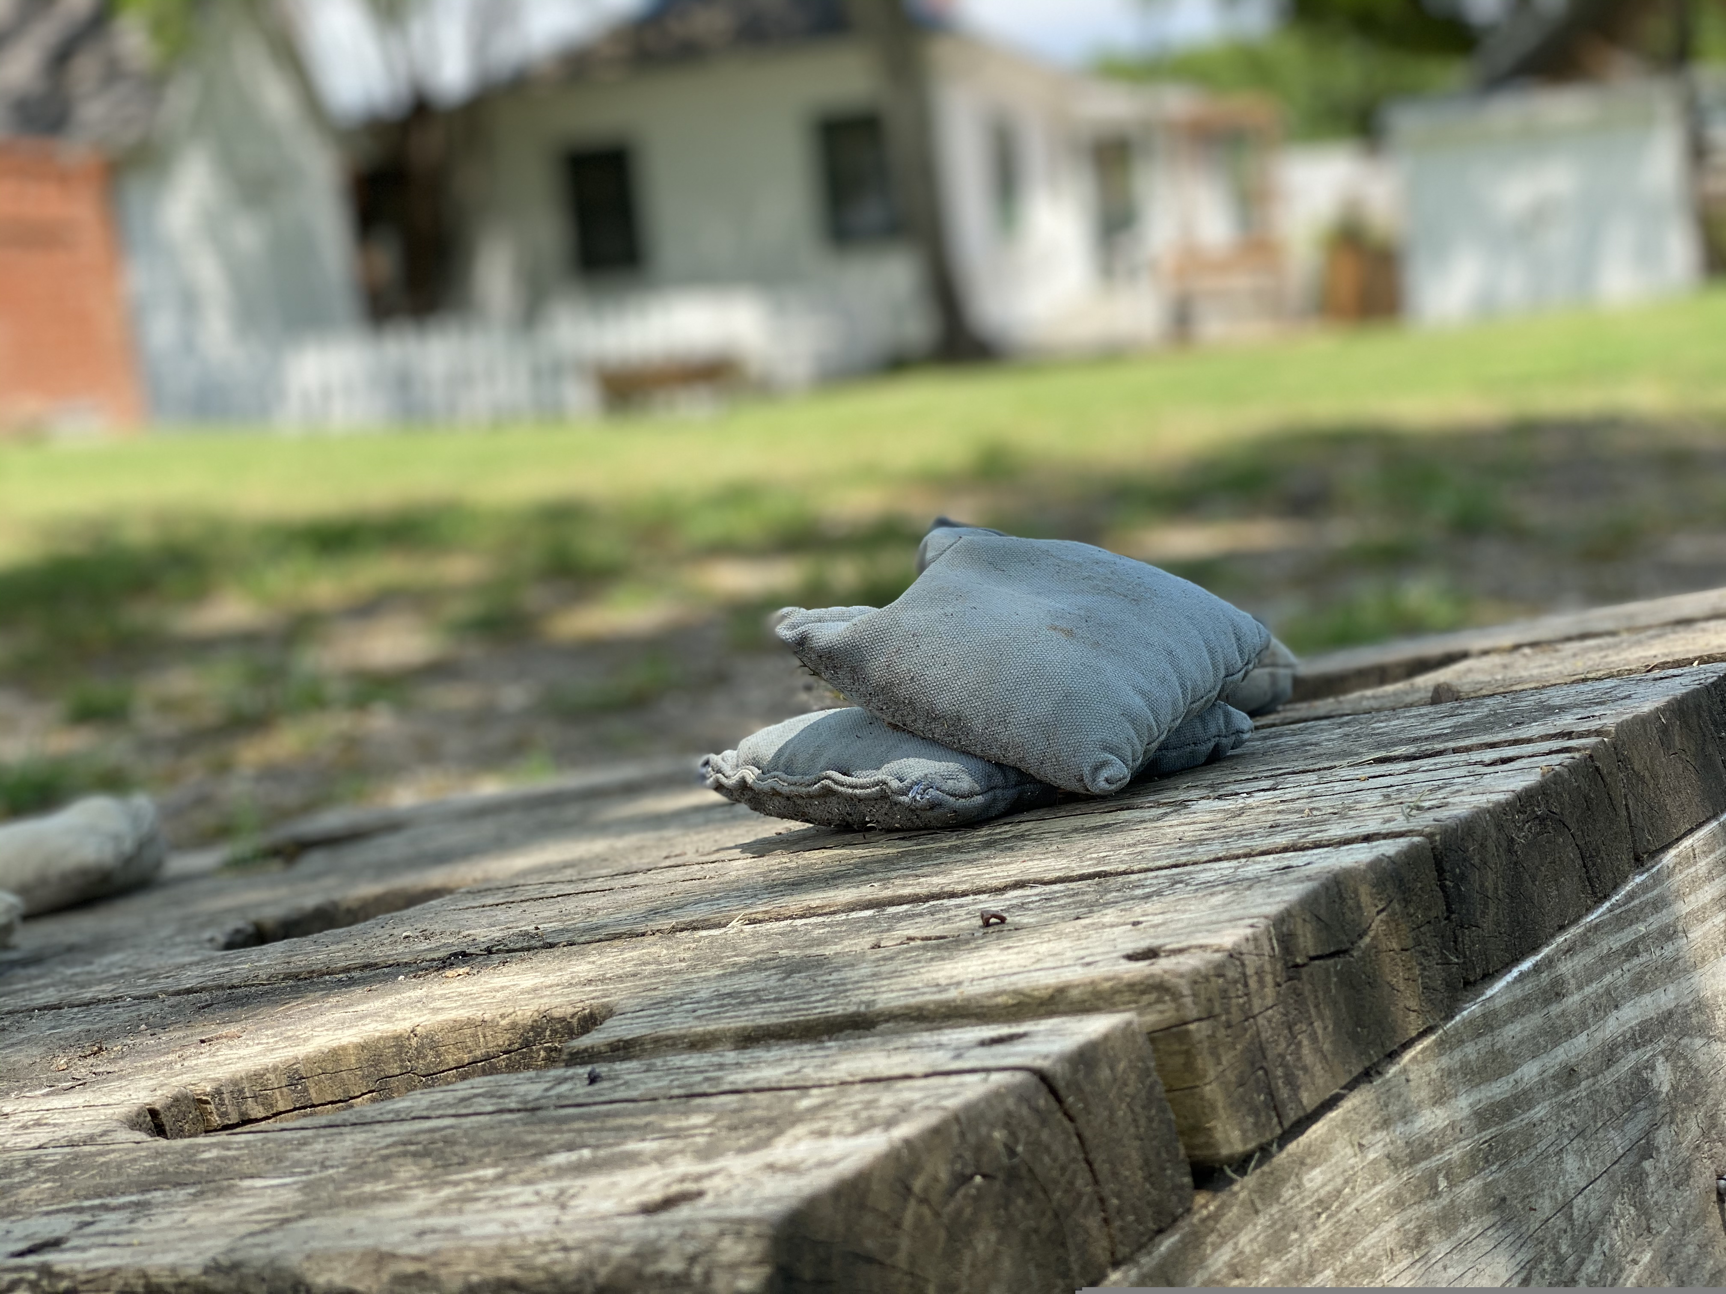

Capacity: Up to 150 people

ADA accessible: Yes

Music: Electrical outlets accessible

Rental Duration: 4 hours

Rental Rate:
Up to 100 people: $450
Additional hour: $125
101-150 people: $700
Additional hour: $175

Refundable Security Deposit: $500
Note: A minimum of 4 hours and/or $850 rental fee required for all after hour events

Items for Rent and Rates for Services Available

Metal Tubs 4 available $10 each
Bales of Hay please request in advance $10 each
Wagon Rides please request in advance $50 per half hour
Use of Fire Pit must have designated person to watch fire $50 per event
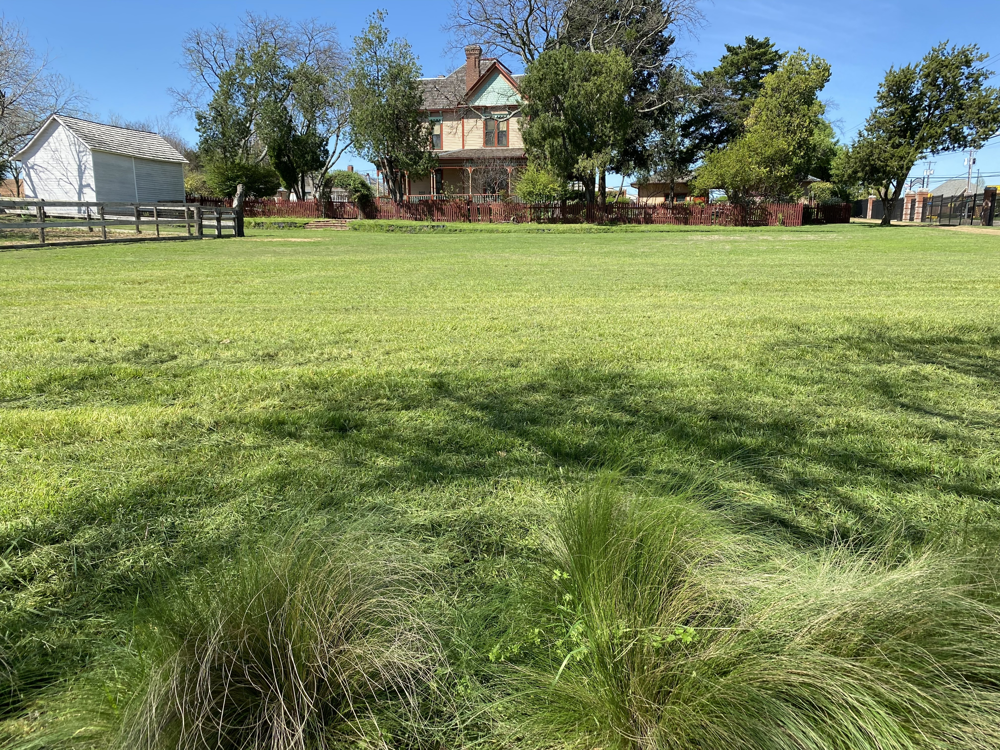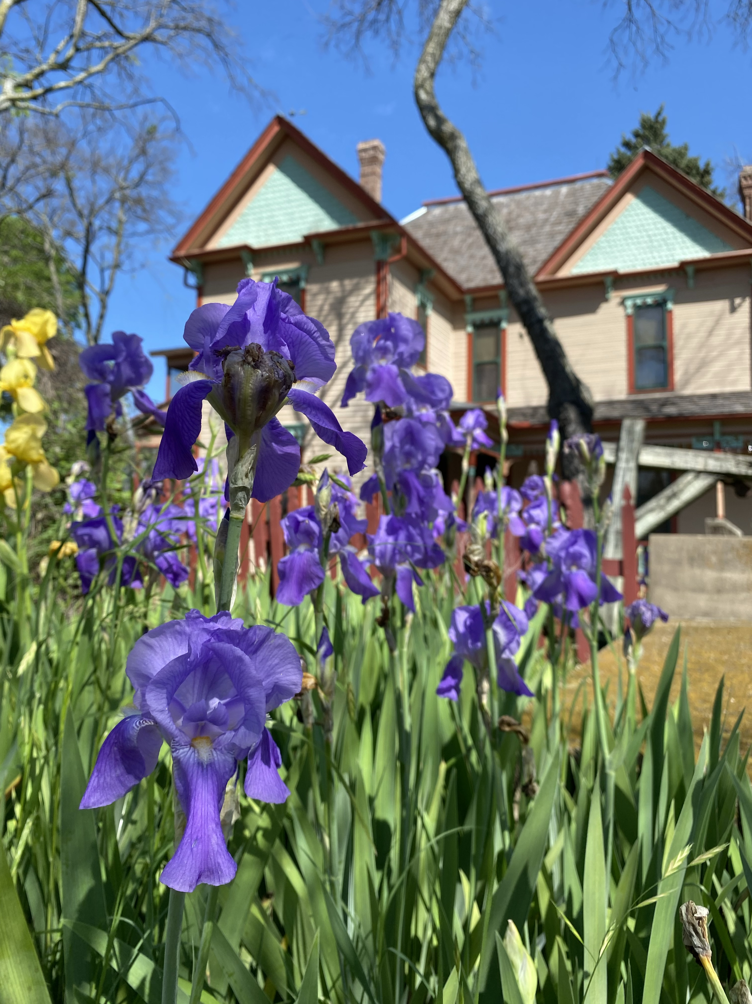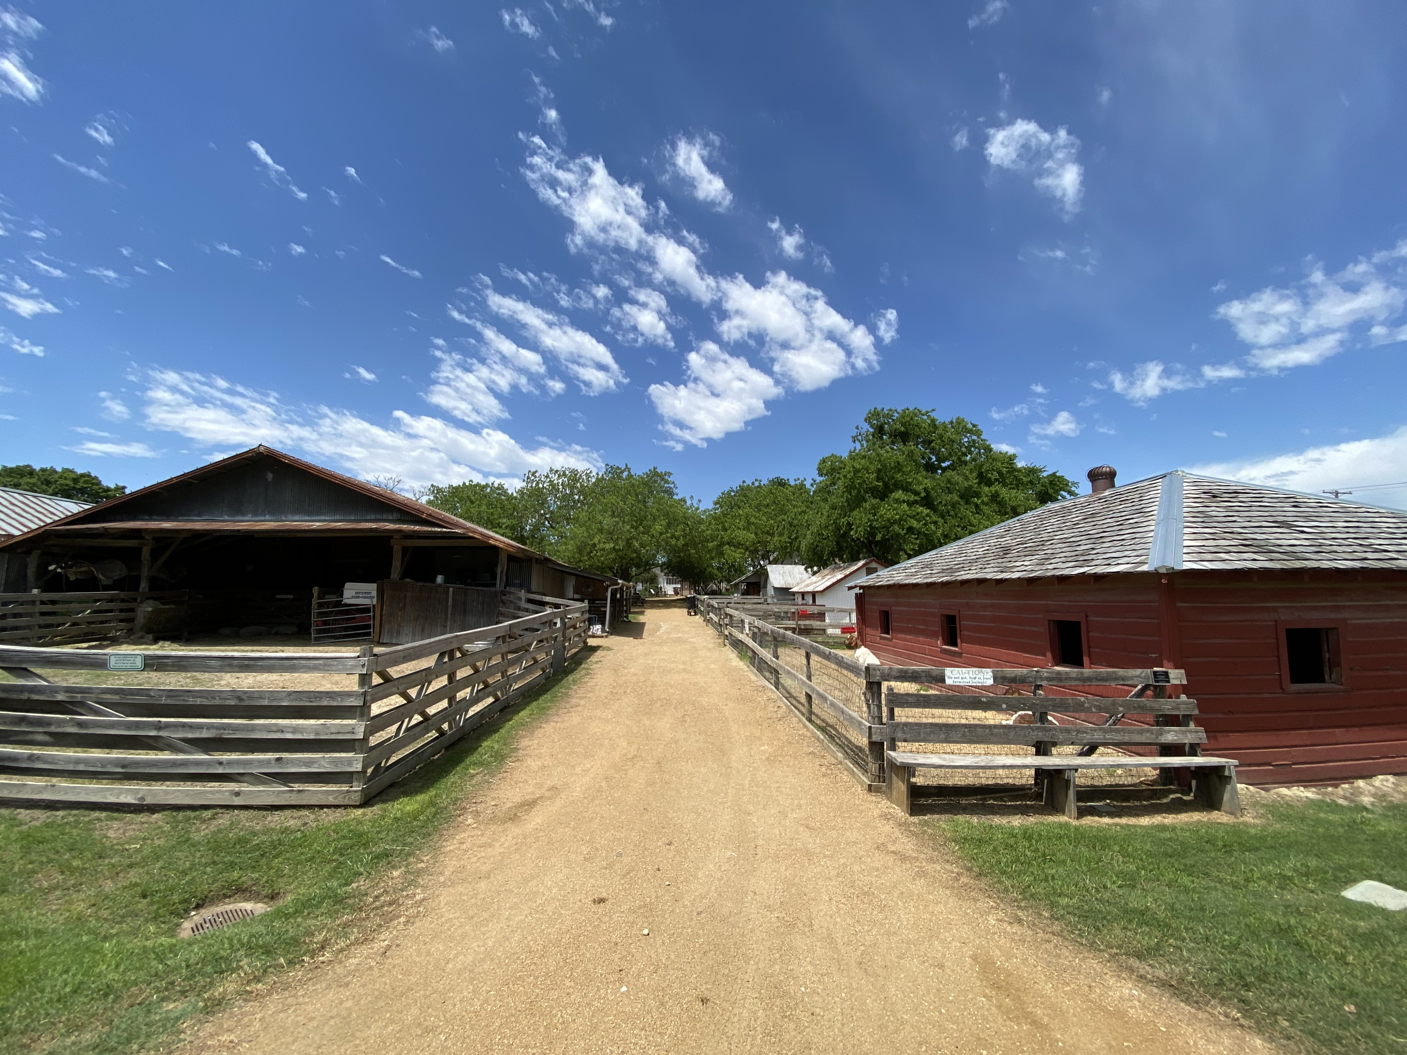

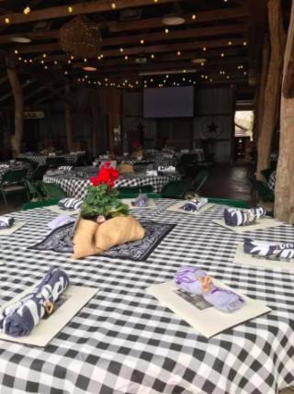

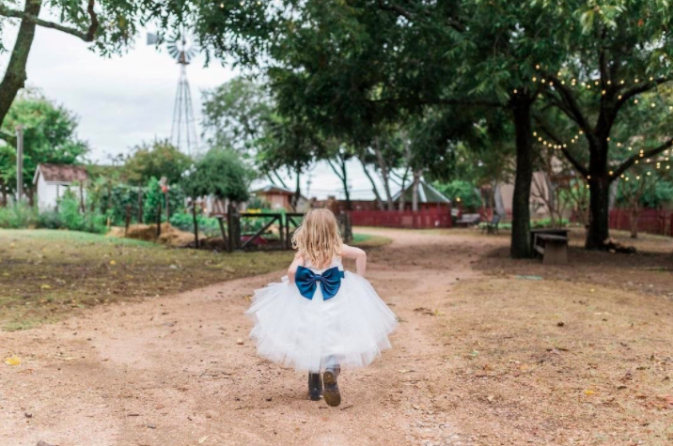
Wedding Packages
Our wedding packages include many extras such as rehearsal time, photography time on the grounds prior to the wedding date, use of bridal dressing room, tables and chairs for up to 150, and much more!

Mary Alice Package (100 guests):
Front/Back Porch Ceremony/Pole Barn Reception $3,000/4 hour event + 2 hours prep time
(Additional hour $500/hour)

Miss Ammie Package (150 guests):
Meadow Ceremony/Pole Barn Reception $2,000/4 hour event + 2 hours prep time

(Additional hour $300/hour

All wedding packages include the following:
- 4 hour event with 2 additional hours for you to decorate, take pictures, and/or clean-up on the day of
- Free self-parking
- On-site security
- Event facilitators dedicated to your event
- Use of bridal dressing room, including 2 bathrooms, located in Young House
- Up to 2 hours of portrait time on the grounds with use of bridal dressing room prior to ceremony date (must be during museum hours, must be reserved in advance)
- Up to 1 hour of rehearsal time (available between 4-6pm the day before the ceremony, must be reserved in advance)
- Use of 60” round guest tables and chairs for up to 150
- For additional charge agreed upon in advance, includes set-up of chairs and tables before event as well as post-event tear-down and trash removal. If service is not used renter is responsible for set up and clean up within 6 hour rental period.

General Policies
  - HFM is first and foremost a nationally recognized historic site – a living history museum, historic home with valuable artifacts, and a working farmstead with live animals with a staff dedicated to education, preservation and public service.
  - Many spaces available for rent by HFM are outdoor and/or not climate controlled. HFM does not provide any back up plan for inclement weather.
  - A local noise ordinance prohibits loud noises and music after 10:00pm.
  - Adult supervision is required at all times for children.
  - HFM is a nonsmoking property.

Payments and Security Deposit
The renter is required to pay HFM a $500.00 refundable security deposit no later than 30 days prior to the rental date. The deposit is a separate fee from the rental cost. Upon the conclusion of the event, provided that all rental conditions are met, the Security Deposit of $500.00 will be refunded to renter no more than 30 business days after rental. The renter agrees to pay a 50% deposit to secure the date for the rental. The remaining balance is due 30 days prior to the rental date.

Alcoholic Beverages
Alcoholic beverages are permitted and must comply with the rules of the Texas Alcoholic Beverages Commission and ordinances of the City of Plano. The renter agrees, by signing the contact, to be responsible for all damages associated with the serving of alcohol. No alcohol can be sold on the premises. Underage drinking is strictly prohibited during any event at the Heritage Farmstead Museum. Those in violation of this rule will forfeit their deposit. Event will be cancelled and police will be called.

Catering
All food delivered to The Heritage Farmstead Museum must be prepared in advance in a licensed kitchen. Use of BBQ grills or deep fryers is strictly prohibited.

Set-up and Clean-up
The renter is responsible for all set up and cleanup of the rented area. If a renter would like to pay an additional fee for set up and clean up please speak with Susan Leigh regarding the fee for this service. Round tables, black folding chairs, rectangular and picnic tables are available for use during the event at no additional cost. The renter is responsible for set-up and tear down of tables and chairs used during the event. At the end of the rental, grounds must be left clear of decorations, litter and debris. All trash should be placed in bins provided. If serving trays containing water area used, the water should be emptied behind the barn facility and not directly in front of the barn.

Decorations
Decorations or signs may not be affixed to any structure, object, or collection with any damaging substances. Free-standing decorations or those suitable attached are allowed. Sturdy votive candles are permitted. Votive candles may only be used in candelabra or other similar holders on covered tables. Citronella candles may also be used during events. No candles should be left unattended. Renters will be made aware of the locations of fire extinguishers. Birdseed and fresh flower petals may be used for weddings on the grounds of the Farmstead with the exception of the parking lot. Confetti, rice and potpourri are prohibited. Balloons and sparklers are strictly prohibited.

